Contents
Background 1
How it works 2
Payroll Condenser Errors 3
Identifying Error Records 3
Unhide EmployeeCheck sheet 3
Check the “Difference” columns 4
Preparing the Data 5
Get the Condensed data 5
Copy the Original data 5
Paste the Original data below the Condensed data 5
Fixing Error Records 6
Check for missing Appointment IDs 6
Check for missing Elements 8

Navigate to: enter > the > navigation > string > here

 | NB: Things you must/must not do.

 | NB: Useful reminders and points to note/for info. The process won’t fail if you ignore this note.

Column1 heading | Column2 heading

Background
The PAYDEP01 Payroll Costings Report is run each month after the final monthly payroll run. It returns the complete pay history for all active staff (casuals and employees) in a given payroll period, e.g. January 2023. We share this data with departments so that they can check their monthly costings.

PAYDEP01 is a large dataset and can easily run to more than 140,000 rows of data. Before we share it with departments, we must “condense” the data into as few rows as possible. To do this, we use a tool called the Payroll Condenser. This is a macro-enabled Excel spreadsheet which condenses the raw data from PAYDEP01 so that there is one only row of data per Employee + Appointment ID + Pay Element combination.

Here’s an example. This is the original data for employee “ABC” relating to their appointment ID “123”. There are six rows of data:

Personnel No | Appointment ID | Element | Gross Value | Employer NI | Employer Pension | Apprentice Levy | Line Total | Total by Cost Centre
ABC | 123 | SALARY | 1766.65 |  |  |  | 1766.65 | 1937.48
ABC | 123 | LONG SERVICE ALLOWANCE | 19.95 |  |  |  | 19.95 | 1937.48
ABC | 123 | EMPLOYERS NI | 0.00 | 1.59 |  |  | 1.59 | 1937.48
ABC | 123 | EMPLOYERS NI | 0.00 | 140.36 |  |  | 140.36 | 1937.48
ABC | 123 | APPRENTICE LEVY | 0.00 |  |  | 8.83 | 8.83 | 1937.48
ABC | 123 | APPRENTICE LEVY | 0.00 |  |  | 0.10 | 0.10 | 1937.48

This is the condensed data for employee “ABC” relating to their appointment ID “123”. There are only two rows of data after it’s been through the Payroll Condenser:

Personnel No | Appointment ID | Element | Gross Value | Employer NI | Employer Pension |  | Apprentice Levy | Line Total | Total by Cost Centre
ABC | 123 | SALARY | 1766.65 | 140.36 | 0.00 | 8.83 |  | 1915.85 | 1937.48
ABC | 123 | LONG SERVICE ALLOWANCE | 19.95 | 1.59 | 0.00 | 0.10 |  | 21.63 | 1937.48

How it works
There are two types of transaction recorded in the PAYDEP01 Payroll Costings Report:

- Elements the University pays to the employee directly (salaries, allowances, hourly rates for casual workers).
- Elements the University pays to other parties which form part of the total cost of employment (National Insurance, the apprentice levy, and any employer contributions to pensions).

The Payroll Condenser looks at all the Elements attached to Employee “ABC” + Appointment ID “123” and condenses the lines for EMPLOYERS NI, APPRENTICE LEVY and any Employer Pension contributions into the lines for salaries & allowances.

Element | Gross Value | Employer NI | Employer Pension | Apprentice Levy | Line Total
SALARY | 1766.65 |  |  |  | 1766.65
LONG SERVICE ALLOWANCE | 19.95 |  |  |  | 19.95
EMPLOYERS NI | 0.00 | 1.59 |  |  | 1.59
EMPLOYERS NI | 0.00 | 140.36 |  |  | 140.36
APPRENTICE LEVY | 0.00 |  |  | 8.83 | 8.83
APPRENTICE LEVY | 0.00 |  |  | 0.10 | 0.10

Of these Elements, only SALARY and LONG SERVICE ALLOWANCE are paid directly to the employee. Th

The Payroll Condenser then moves the values for EMPLOYERS NI and APPRENTICE LEVY into the columns named “Employer NI” and “Apprentice Levy”:

Payroll Condenser Errors
The final step in the Payroll Condenser process involves an automatic comparison of the Original payroll data to the Condensed data, to check that the values match between both datasets. The results of this automatic comparison are output to a worksheet called Final Check Figures. If there are any mismatches in the data, they will appear as errors in the Final Check Figures worksheet:

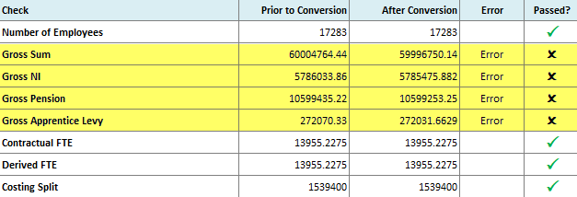

The total number of error records is shown in the lower half of the worksheet:

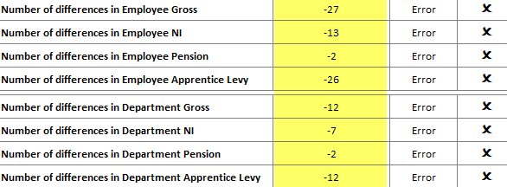

You will need to fix these errors before the Condensed payroll data can be forwarded on to departments.

Identifying Error Records
Begin by identifying the error records, as outlined below.

Unhide EmployeeCheck sheet
Right-click on any worksheet and select “Unhide…”. In the pop-up window, unhide the EmployeeCheck sheet:

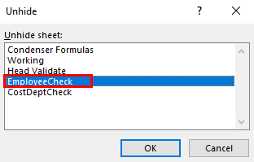

Check the “Difference” columns
Within the EmployeeCheck sheet, you will see a list of personnel numbers alongside columns comparing the Original data to the Condensed data for each personnel record. There is a “Difference” column beside each comparison:

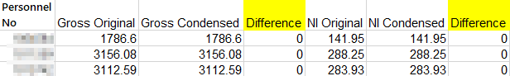

Apply a filter to the worksheet and filter the first “Difference” column (next to the “Gross Original” and “Gross Condensed columns) for non-zero values by unticking the “0” value:

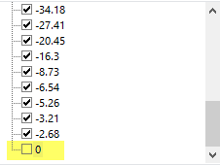

The non-zero values in the “Difference” columns indicate mismatches between the Original and Condensed data. The personnel numbers in your filtered dataset are the error records you need to correct.

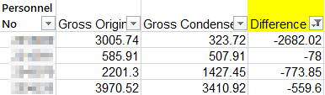

Preparing the Data

Get the Condensed data
Once you’ve got the error records in the EmployeeCheck worksheet, go to the Condensed worksheet and search for the first personnel number in your list of error records. The Condensed payroll costings data for that employee will be displayed, grouped by Appointment ID. In the example below, the employee only has one row appearing in the Condensed worksheet:

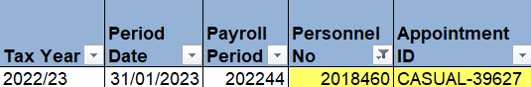

According to the EmployeeCheck worksheet, the Condensed data doesn’t
match what’s in the Original Data worksheet, so you must get the Original data in order to do a comparison.

Copy the Original data
Go to the Original Data worksheet and search for the same personnel number. The Original payroll costings data for that employee will be displayed, grouped by Appointment ID. In the example below, the employee has six rows appearing in the Original Data worksheet:

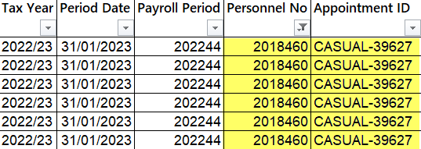

Select the rows and enter CTRL+C to copy them. Be sure to select every column from A (Tax Year) to AH (Total by Cost Centre).

Paste the Original data below the Condensed data
Go back to the Condensed worksheet (which should still be filtered for the error record you’re investigating). Enter CTRL+V to paste the Original data rows into the worksheet, below the Condensed data rows:

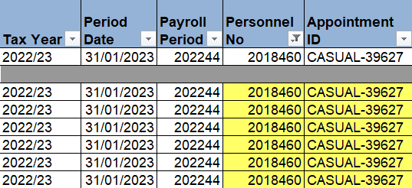

 | NB: always leave a blank row or two between the Condensed data (at the top) and the Original data (beneath). This will ensure that you don’t confuse the two sets of records!

Fixing Error Records
You are now ready to do a visual comparison of the Condensed data to the Original data for each error record, to see where the mismatch has occurred.

Generally speaking, errors occur because the Payroll Condenser has “skipped” records when condensing the payroll data for an employee. You must therefore check whether the Condensed data rows contain the same information as the Original data rows in the following columns:

- Appointment ID
  - The Original data may contain more Appointment IDs than the Condensed data. If this is the case, you’ll need to add the rows for the missing Appointment IDs to the Condensed data to resolve the error.
- Element
  - The Original data may contain more pay elements than the Condensed data. If this is the case, you’ll need to add the rows for the missing Elements to the Condensed data to resolve the error.

Check for missing Appointment IDs
Compare your Original and Condensed data. Are there any Appointment ID values in your Original data that don’t appear in your Condensed data?

Example 1: no errors. The same Appointment ID appears in both Condensed data (above) and Original data (below). If this is the case for your current record, move on to check for missing Elements.



Example 2: errors. There is an appointment ID present in the Original data (below) which is missing from the Condensed data (above). If this is the case for your current record, continue to follow the process below.

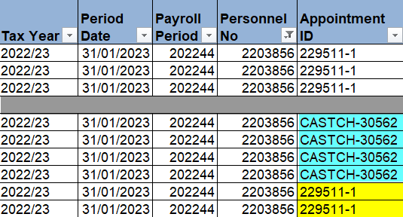

Prepare the Original data
In your copy-pasted rows of Original data, remove any non-error rows – you only want to keep the rows for the missing Appointment ID:

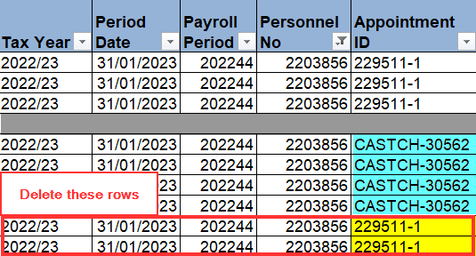

Condense the data
You now need to manually condense the data for the missing Appointment ID before you can add it to the Condensed data.

- Line Total: Delete any rows in your Original data where the “Line Total” = “0.00”:

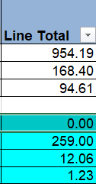

- Element: There should be a line for each Element an employee was paid against in the payroll period. “Employer NI”, “Employer Pension”, and “Apprentice Levy” are not Elements, they are separate costs paid by the University.

Insert a new row
To add the missing Appointment IDs to the Condensed data, right-click within the rows of your Condensed data and select “Insert Row”:

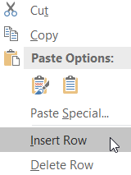

A blank row will be added to your Condensed data. This is where you will enter the information for the missing Appointment ID.

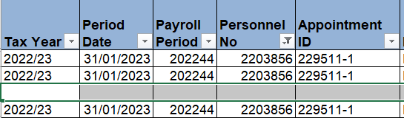

Check for missing Elements
If there are no missing Appointment IDs, you need to check for any Element values in your Original data that don’t appear in your Condensed data.

Example 1:

